Work report 11 august 2021

Today I have trained yolo v4 with

1. Mixup
2. Blur augmentation till 3000 epochs

Results are as follows:

For 1500 epochs:

1. Train

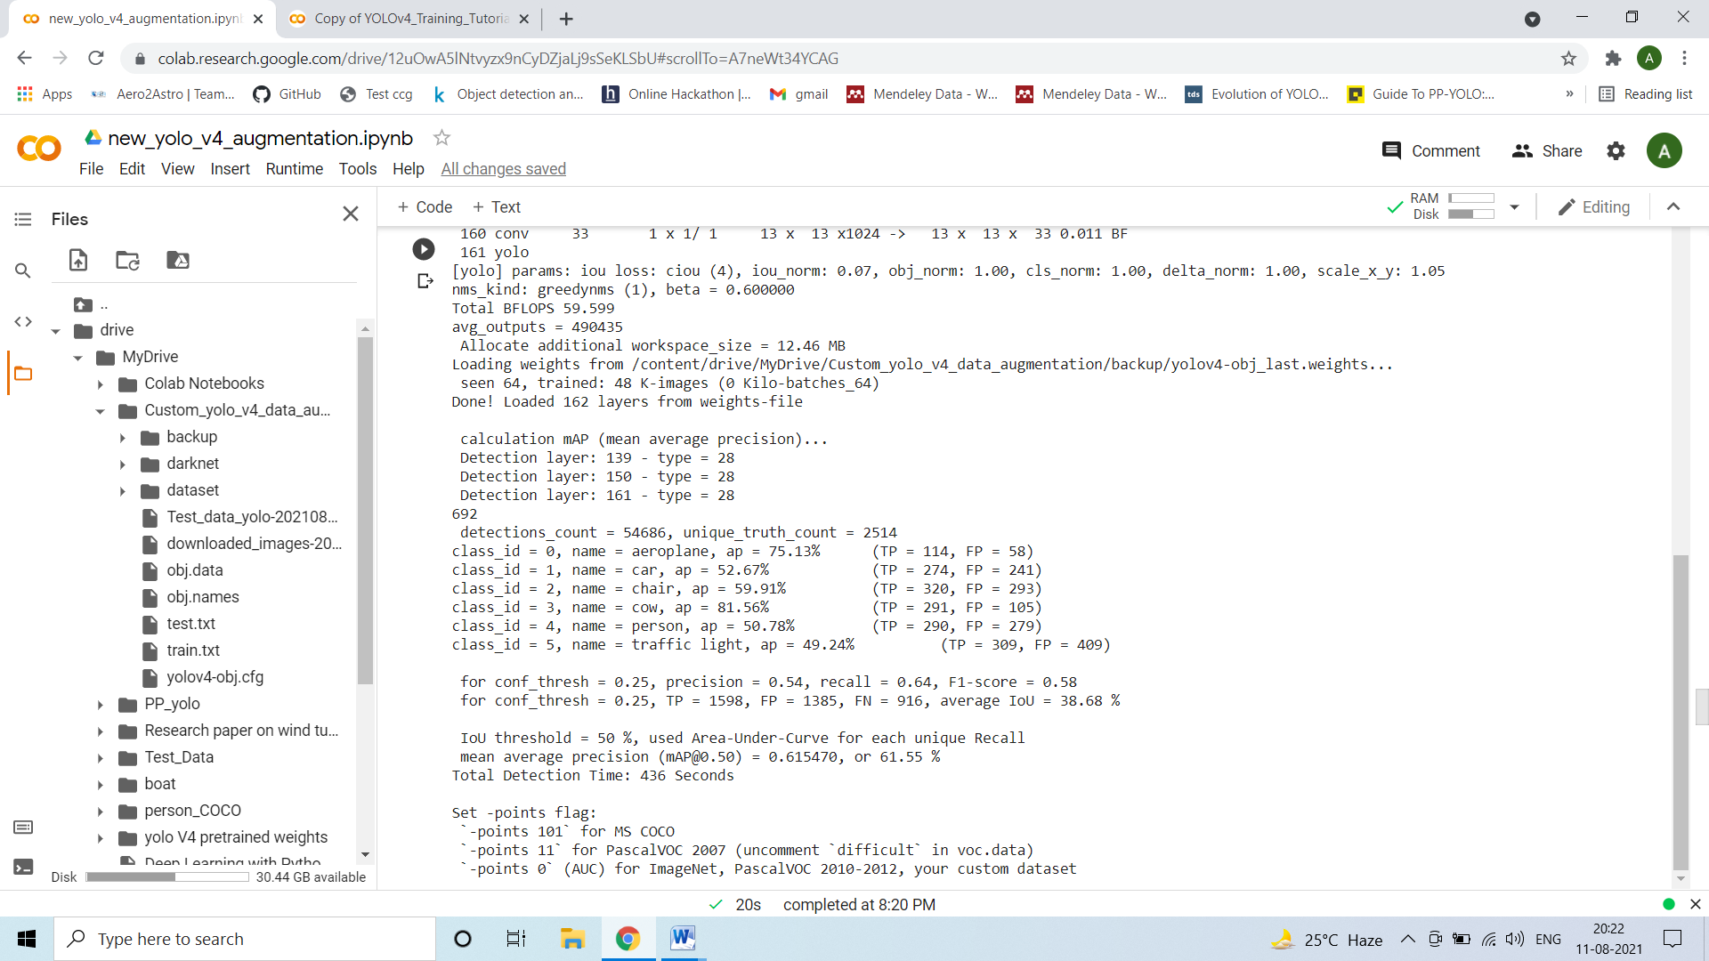

1. Test

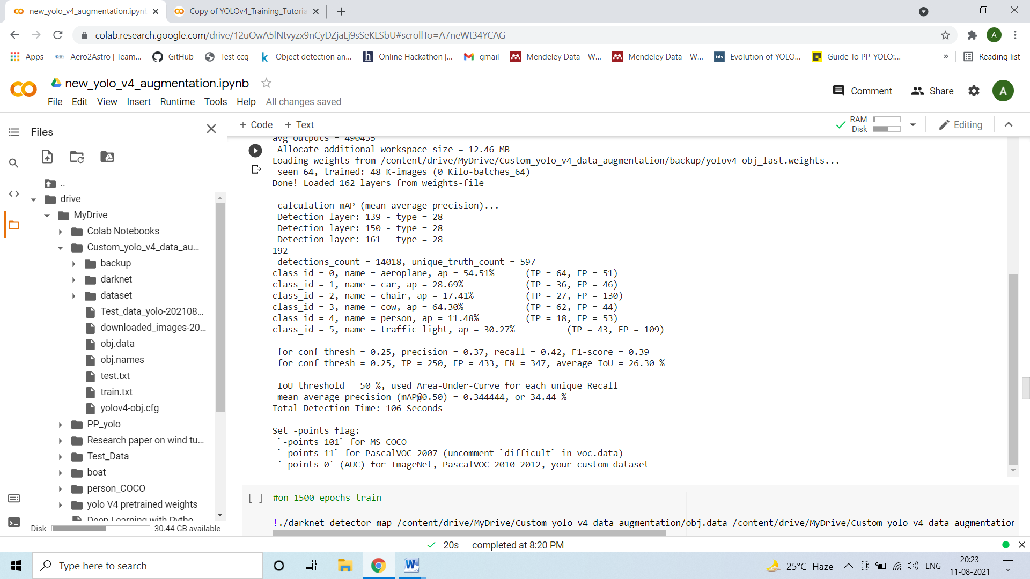

For 3000 epochs

1. Train

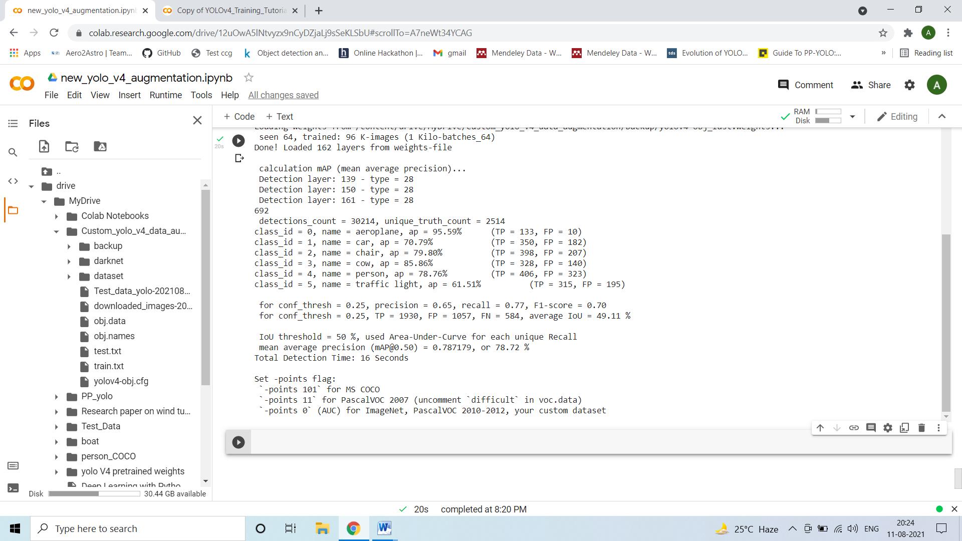

2.Test

